**Current Process / Work Flow for digital fixing** :

1. Channel scans the documents through HDFC & you app under relevant heads like sale deed , advocate letter , intkal etc. along with web DRF
2. Center captures the title documents from Legal Workbench > Doc maintenance
3. Disbursement Fixing hub review the scanned documents from Disbursement Document tracker .
4. Disbursement hub track the cases from Disbursement work flow > Review / Raise the FR's
5. After reviewing all documents , special condition , seller/ payee details , appraiser fixed the file

**Current Process / Work Flow  with system screenshots**

Channel scans the documents through HDFC & you app under relevant heads like sale deed, advocate letter , intkal etc. along with web DRF

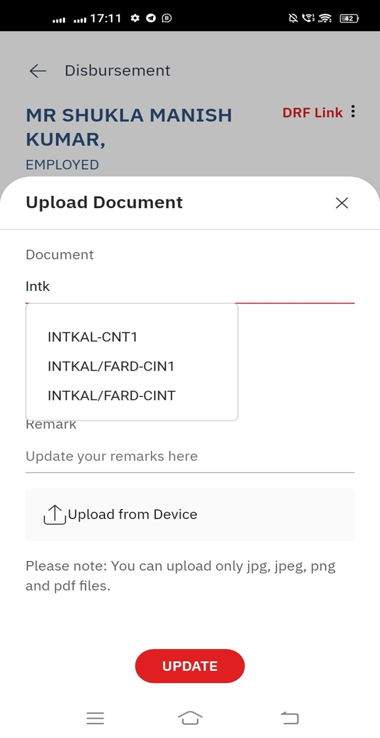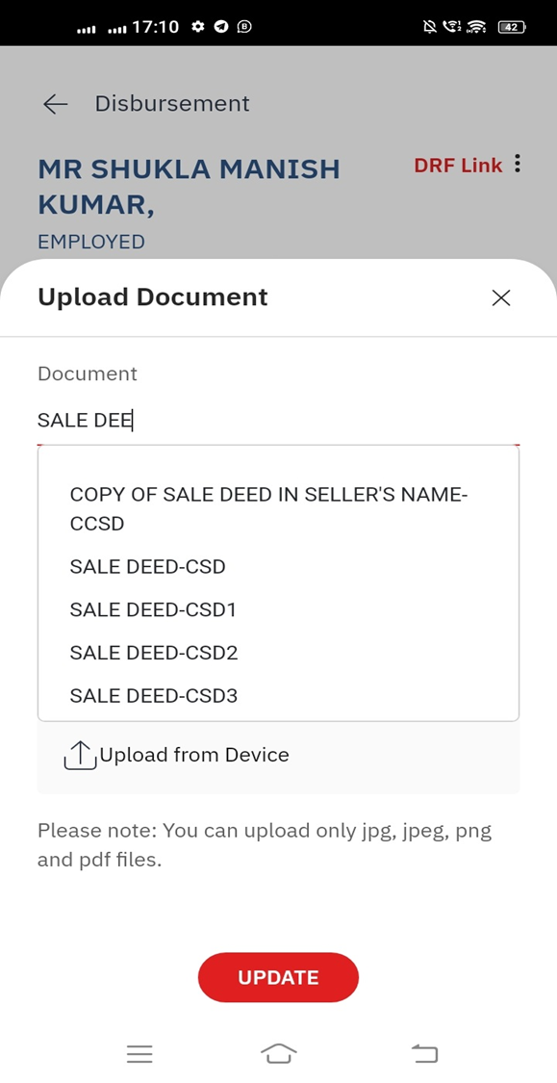

2. Center captures the title documents from Legal Workbench > Doc maintenance

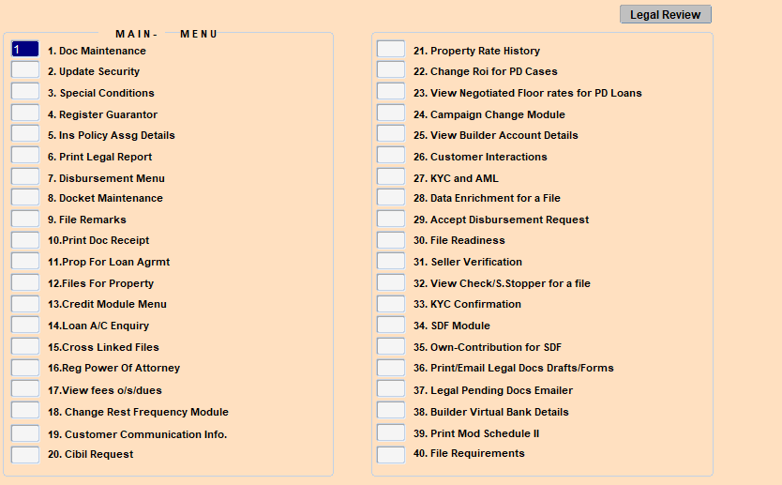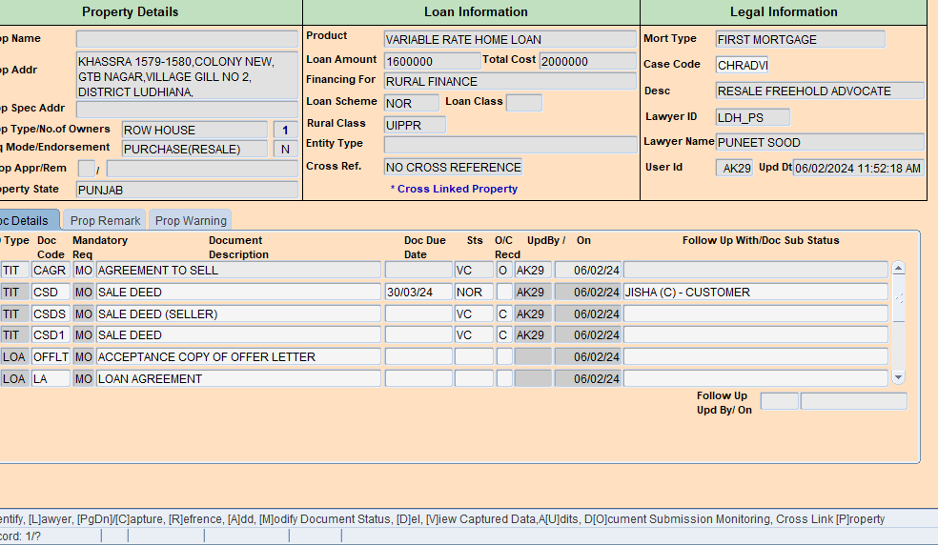

3. Disbursement Fixing hub review the scanned documents from Disbursement Document tracker .

**ILPS > Disbursement process module > Disbursement Document tracker**

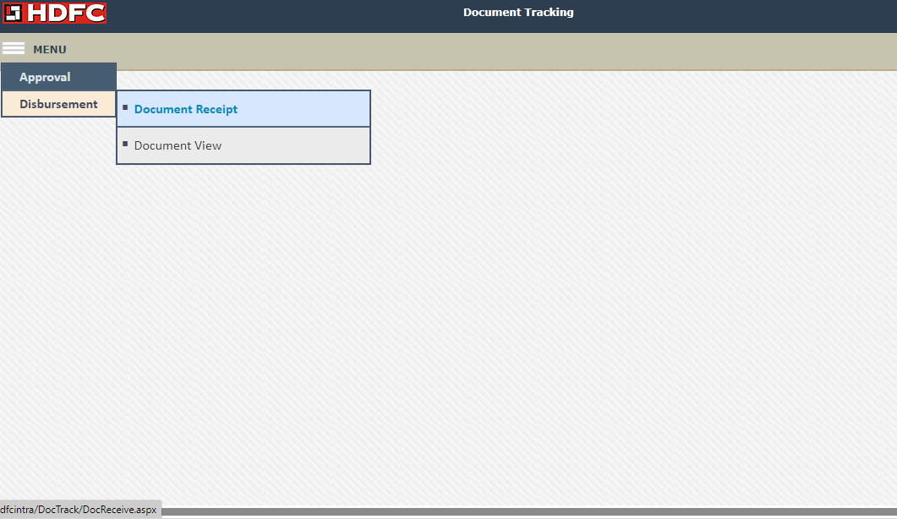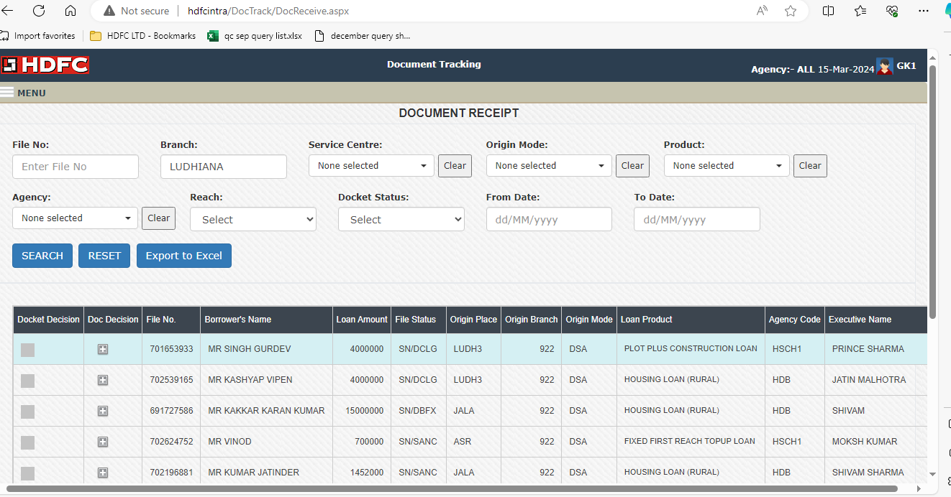

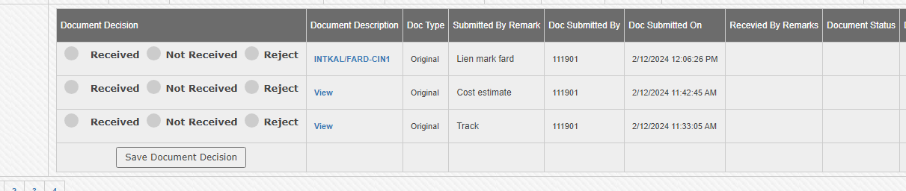

If disbursement hub selects not received option then remarks put up are not visible to channel.

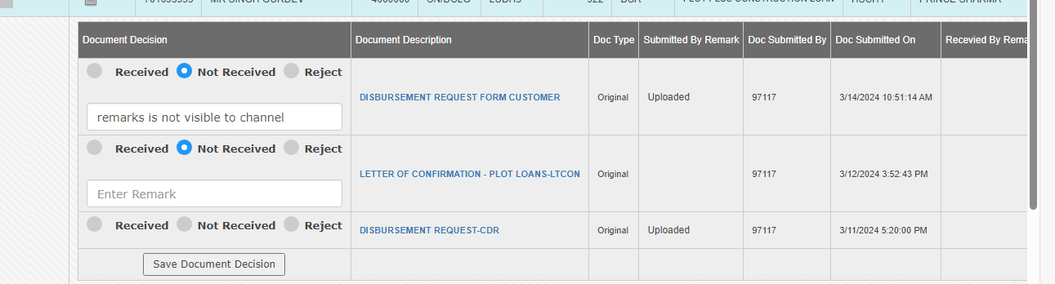

4. Disbursement hub track the cases from Disbursement work flow > Review / Raise the FR's

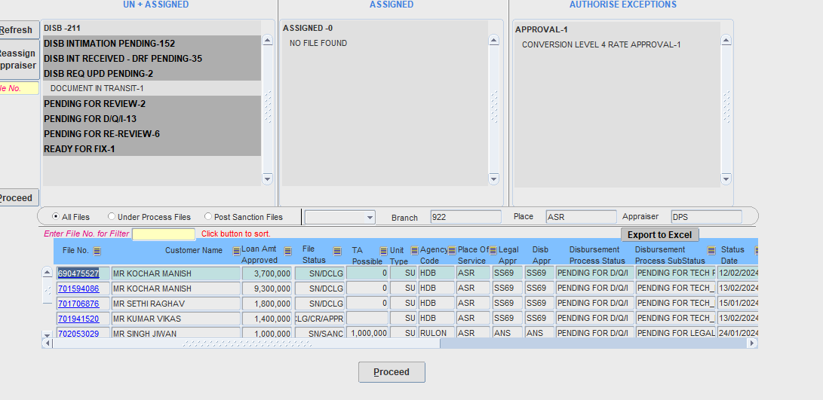

5. After reviewing all documents, special condition, seller/ payee details , appraiser fixed the file

**ILPS > Disbursement process module > Fix Disbursement**

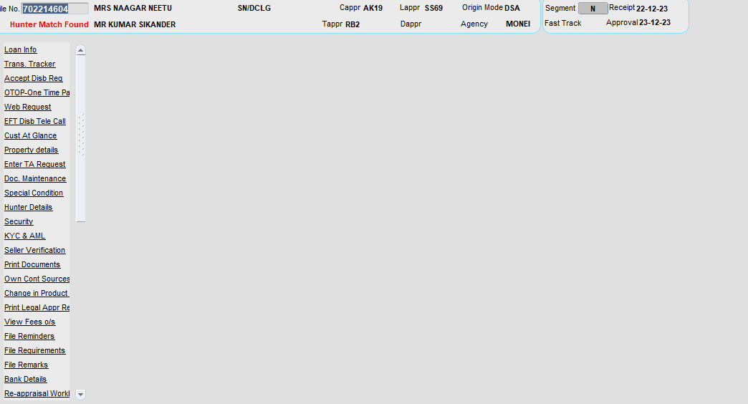

**Challenges / Suggestions :**

1. Only channel has an option to scan the documents . Service center staff is not having access to scan the documents for digital fixing .

Service center can scan through “ Upload documents” but that will not reflect under document tracking module.

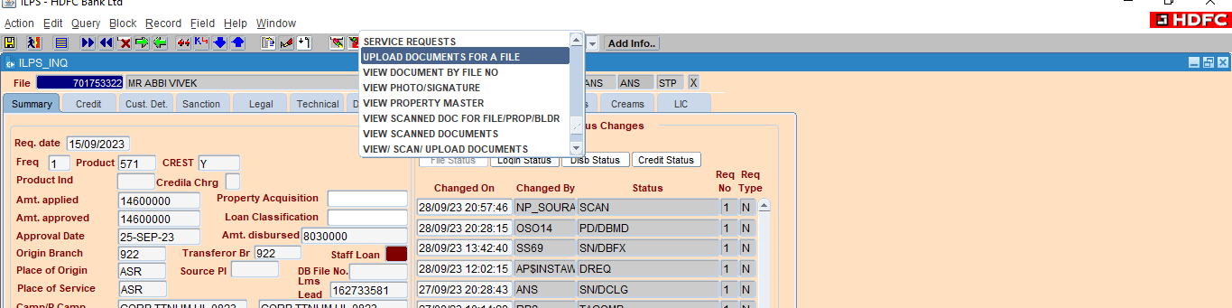

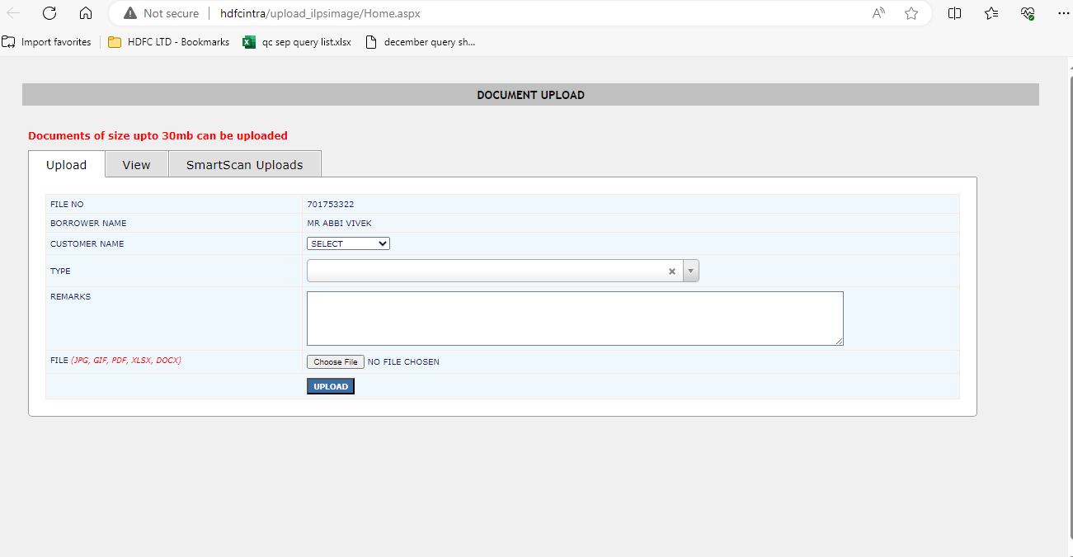

 Service center scans the documents thru Quick scan / Waves dashboard , which does not reflect under Disbursement document tracker.

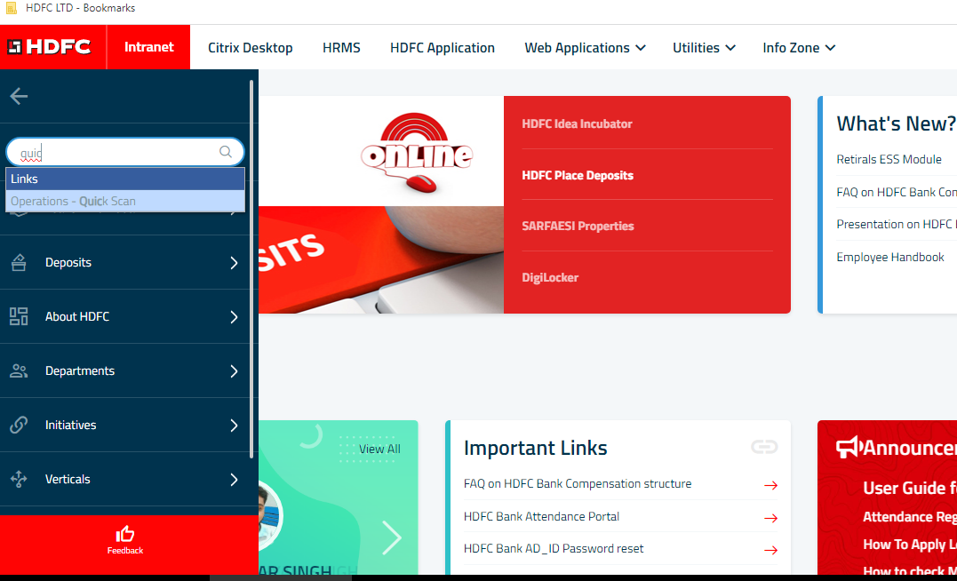

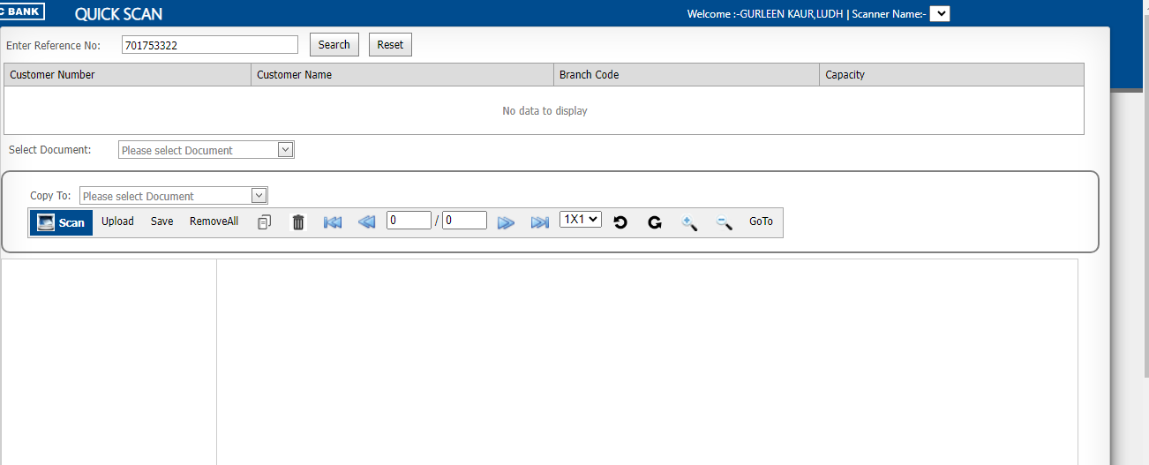

       2.  At present , We are using 3 different modules are view / review of documents

      - Disbursement document tracking module for viewing the scanned title documents.

      - Disbursement work flow to review / raise the FR

      - Legal workbench to check the correctness of capturing of legal documents

Please see , if we can integrate legal workbench to view the scan documents , it will save time for view / review the legal documents .